SIDE NOTES  1. A way of drawing extrapolated from -  Deligdisch P, 2013, Line of Thought, An Art Collection by PeterDraws  SIDE NOTES  2. Deligdisch P, 2013, Line of Thought, An Art Collection by PeterDraws  SIDE NOTES  3. Deligdisch P, 2013, Line of Thought, An Art Collection by PeterDraws  4. Adams, D. (2004). The hitchhiker's guide to the galaxy. New York: Harmony Books.  SIDE NOTES  5. Yotam Ottolenghi Quotes. (1968.). BrainyQuote.com. Retrieved May 31, 2020  SIDE NOTES  6. Willard, F. (2008). WALL-E. Burbank, Calif: Walt Disney Home Entertainment.  7. Niccol A, 2011, In Time, Abraham M, Newman E, United States, New Regency Strike Entertainment  SIDE NOTES  8. Tang Jia San Shao, 2008, Douluo Dalu, Qidian  9. Traditionally Megalodon’s is a term describing giant sharks - but in the Knock Rift they represent huge rift dwellers of monstrous size.  SIDE NOTES  10. Deligdisch P, 2013, Line of Thought, An Art Collection by PeterDraw  11.Dave & Greg, n.d, United States, creaturebox.com  12. Sanz M, n,d, United Kingdom, mattsanz.artstation.com  SIDE NOTES  13. Murray S, 2010, Jungian Psychoanalysis: Working in the Spirit of Carl Jung, Carus Publishing Company, pg.95 | Thesis Report 2020 - Submitted in part of the requirements for the degree of Bachelor of Design (B.Des.) In Visual Communication Design At the Beaconhouse National University.  Submitted by Fozan Tariq  Registration: S2016-059  THE WORLD OF THE KNOCK RIFT  KEYWORDS:  world building, illustration, amalgamation, society, trash, aliens, scrap, sci-fi, space, rift, city, creatures, technology, junk, story telling, life, chaos  ABSTRACT:  A world is built upon many different complex systems. Authors have developed many fantastical worlds that can be found in between the pages of famous books. These worlds have intricate and detailed thoughts behind them, letting the worlds immerse the audience. The Knock Rift aims to be another. A place where the worthless live as if they still have worth. The world of living trash.  Even when the denizens of this land have to sell off pieces of themselves, they will do so in order to survive. The many factions scheme against each other in order to obtain more resources. The differences between the poor and the rich divides the people. These are just some of the systems belonging to the Knock Rift that create parallels to our reality and give realism and relatability.  The Knock Rift is a strange place where due to many freak coincidences, a teeming society of living alien trash thrives in a chaotic mess.  Through in-depth written and visual development this dissertation seeks to give the audience a window in which to take a peek at the world of the Knock Rift.  PASSION:  I have struggled with my lack of ambition my entire life. From a young age I was often compared to my brother, who would gain success with ease when I found it difficult. Instead of facing my problems and choosing to overcome them through hard-work, I would run away.  A vicious cycle of being a troublemaker and a problem child followed. Right up to when it was time to make a decision with what I wanted to study at the end of high-school. Initially I halfheartedly chose to become a computer science major, which I lacked the discipline and knowledge for - and began to flounder in life once again.  By chance, there was a joint project during my computer science program with the students of the graphic design program. We were to make a phone application together. Immediately I became interested in the graphical aspect of the project more so than my own field of study.. As the discussions progressed, I found myself mesmerized for the first time in my life, Perhaps design was my true calling.  As I switched majors to design and years passed, I realized that some old bad habits were hard to end. Although I had changed and found some focus, often I would still struggle with old problems regarding work ethic and study. It was difficult to move forward… But for the first time in my life I felt as if things were coming together. All those years of reading books or doodling, were helping me achieve some level of competency.  I had never believed my love for reading and writing would be useful, but in design these can be key skills. I had never believed that the cartoons and comics I drew in my notebooks would lead to anything, yet now they have led me to come far.  My doodles are now my designs. My fleeting thoughts are now my worlds. As a visual communicator, my ways of escaping reality have become my ways in which to thrive in it.  PROJECT SCOPE:  This project seeks to establish a mirror into which the audience can take a look at a strange world, one which seeks to create interest and entertain.  DESIGN STATEMENT:  The world of the Knock Rift is a place unlike any other. In today's society we have access to content from a very wide variety of sources and making original work has gotten a lot more difficult. From a young age I have always been interested in science fiction and the works of many authors who created odd and strange worlds. Taking inspiration from works such as these as well as mixing and hashing my own ideas, I have created a world of living trash. This world hopes to bring some originality to the already saturated space of science fiction. Using illustration as the main method to show the world, I seek to visually craft a place others can view. The design of the characters and environments come from the illustration philosophy of ‘line of thought’¹.  The medium of the dissertation will come as an illustrated encyclopedia / art book. Featuring illustrations with interesting compositions using environment and character design. These will present detailed pieces with accompanying flavor text that help to bring context to the images. Elements of design such as type and info-graphic-inspired simple illustrations will also be utilized when appropriate to give the reader additional insight into the workings of the world of the Knock Rift.  This form of execution is rarely found among other contemporaries of the industry. Concepts and illustrations that come in art books are not often used in such a manner - to serve as the basis of crafting an entire world.  This project thus also aims to introduce a fresh and more detailed method of bridging the gap between illustrators and authors. Visual exploration and world building can first be tested within an illustrated encyclopedia that can then be used as the framework for further explorations of the work, such as full feature films or comic-books. The idea is to scale up the process of concept art, and create a more detailed and grounded method of presentation and exploration.  The illustrated encyclopedia in certain ways represents the importance of timing, my dissertation in some ways also exists as a proposal to give studios a method to create a database to be crafted first rather than later. In industry practice, art books containing concepts are often created after the final result, which can create possible pain points for the project. The idea to create a reference book for internal use and external use in the initial stages, can smooth over certain elements of a team's direction and work-flow.  RESEARCH QUESTIONS:  Q1.  How do I make a unique world? In a time of many ideas not being very original, how do I foster an approach that lets me develop an original world told through visual communication?  Q2.  How does this world’s society function? What sort of parameters affect my world? How do the creatures of my world interact with one another?  Q3.  What do the creatures of my world look like? What separates an individual from another?  THEORETICAL FRAMEWORK:  Using a combination of illustration and story-telling, this work seeks to bring the Knock Rift alive. The main elements of visual design used in the illustration of my work are heavily inspired by self taught artist Peter Deligdisch². Peter is known for his illustrations and doodles that rarely feature a subject matter but rather derive their shapes and forms from his imagination. He draws with his uncanny sense of tempo and manages to create amazingly detailed pen illustrations. In his you-tube videos he talks about the philosophy behind his art as he believes that art contains a reflection of himself and his subconscious thoughts - he has perfected the art of ‘doodling’.  Concerning ‘line-of-thought’ illustrations, rather than having fixed ideas and pre-planned executions, it is more important to keep a sense of rhythm and tempo and gradually begin applying certain references or ideas to the artwork.  Peter Deligdisch’s art book³ and his videos further explain and expand on these concepts and their uses. It is an almost spiritual process, Peter tries to tap into the corners of his mind and focuses on the nuances of line and shape and his own feelings regarding the images he’s creating as he is creating them.  This process and design philosophy fit the world I was building very well, and forms the core of the world of the Knock Rift’s visual development. Studying Peter’s methodology and his illustration style further let me get a grasp on how to emulate it in my own style and create visual complexity that makes the world of the Knock Rift look unique and distinct.  The story-telling aspect of my world comes from certain elements of Douglas Noel Adams famous work ‘The Hitchhiker’s Guide to the Galaxy’⁴. The Hitchhiker’s Guide to the Galaxy features a man named Arthur Dent, who undertakes an adventure across the galaxy. Throughout the book Douglas Adams draws some parallels to our reality and his science fiction adventure in space. Peppered through his books are situations that are used as examples that reflect certain elements of our own world, and using his own wacky and humorous situation to describe some of the more ridiculous elements of his own life. An example of this is the famous “Don’t Panic” phrase used in the hitchhiker’s guide, as an advice towards galaxy travelers in the book. The repetition of this phrase parallels the United Kingdom government’s own methods of dispelling anxiety when the British were suffering through difficult times and war.  The world of the Knock Rift also uses this similar method of story-telling, drawing certain parallels to our own reality, and describing certain situations that comment on the state of our world.  The systems that divide the rich and the poor in the world of the Knock Rift are systems that you can find in our world as well. In the world of the Knock Rift, the rich have economical and territorial power, as they control access to the largest trash heap in the world as well as the Slurp Lake, the greatest source of food and sustenance for the people. This power has led the rich to become more corrupt over time, leading them to monopolize more resources and become not willing to share with other rift dwellers.  This is just one example of parallels that are drawn between reality and the world of the Knock Rift. These parallels seek to create interest as well as engage readers to think about similar real circumstances and perhaps ask questions regarding them.  CONCEPT:  “One man's trash is another man's treasure” (Yotam Otteolenghi, 1968)⁵  This quote is a particular favourite of mine as it presents a type of distinctive mindset that I always found commendable. The heroes I have always thought of fondly are not those who are courageous and valiant but rather those who present a more gaunt attitude. The heroes who struggle and suffer and finally overcome adversity have always been more relatable to me.  I interpret that the quote itself directly alludes to the reality that those who are in sufferance or poverty can obtain value from something that another would carelessly discard.  This quote sparked the beginning of an idea that grew into the world of the Knock Rift. After taking this quote as the base, as well as adding some more traditional science fiction elements, I was able to start putting together the skeleton of the body that would make my world.  The world of the Knock Rift is a place belonging to inhabitants created from living trash, trash itself becomes a necessary component to their daily lives. Their concept of what is useful and not useful is blurred to the point of individual preference, rather than a societal dictation. Yotam’s quote thus takes a hold of the core of systems of the world, in a very literal sense.  LITERATURE REVIEW:  To further study and understand my direction I first decided to take a closer look at the work of other science fiction artists and authors who have created successful and vibrant worlds of wonder. The first of such worlds that shared some similarities to my world was Pixar’s Animation Film ‘Wall-e’⁶. After reviewing and analyzing the film and what sort of inspiration I could take from the film, I found myself interested in the trash world of future earth. The visuals of the movie helped me understand the sort of direction I could take for my environmental design work. Additionally, the attitude with which the rift dwellers of the world of the Knock Rift could take when scavenging through heaps of trash could reflect the attitude of Wall-e.  Wall-e’s main character is an old robot who presents a curious attitude towards the trashed earth and derives entertainment from his surroundings.  My thoughts then led me to search for literature that expands more on the economical aspects of science fiction, from which I can glean information that can be applied to the infrastructure of the world of the Knock Rift. But despite my searching, It was difficult to find science fiction works with creative economic systems.  ‘In Time’⁷ happens to be such a work. ‘In Time’ is a film where time itself is used as currency in a future human society similar to ours. In this movie, Time is used both as something useful for staying alive as well as a resource to trade with others. In the movie, aging is no longer a problem, humans have managed to solve aging and everyone has become pseudo-immortal. But the catch is, to stay alive, you must work for time, instead of money - and time itself has become currency, being poor or in poverty eventually leads to death. This duality towards currency sparked some interest within myself. Perhaps a similar duality could be used in an interesting way within my world?  Using this concept, I developed ‘Slurp’. A liquid that gives life to all denizens of the Knock Rift. Slurp has three main functions, firstly as their main source of sustenance, without Slurp, the rift dwellers will slowly die off from starvation. Another function of Slurp, is its ability to bring trash to life. Certain high concentrations of the Slurp liquid reacts when near trash and manifests life. The final function is Slurps purpose as currency - since it is required by all life on the knock-rift for other reasons, slurp remains as one of the main forms of currency.  Another form of currency and resource that exists in the knock-rift comes in the form of trash. Many different types of trash exist in the Knock Rift, trash that possess technology from other alien races, trash that contains strange organic matter - or even trash that is simple degraded objects. The variety of such strange things provides a complex trading system to the world. No creature of the world is similar to another, and so each of them also have different preferences and desires when it comes to assimilating and changing their very vessels with new types of trash. Their own bodies have direct monetary value, and so does trash that can be found scavenging all around the rift.  Douluo Dalu⁸ is a Chinese novel that I did not expect to be able to seek inspiration from. I originally studied fiction among western works but after some time, I began looking towards eastern writers. Chinese literature and books as well as Korean and Japanese literature is a wholly untapped source of insight by non-native speakers around the world. Due to the high-bar of entry, very few understand the depth and explosive popularity even among a young audience that these eastern novels have.  Yet in recent years many online websites have begun translating these novels in hopes to expose them to western audiences. Douluo Dalu is such a work. The story features a man possessing memories of another life. He wakes up in a strange world of ancient mystical china, where beasts and creatures live in a strange harmony with humans. Humans have managed to harness the abilities of mythical creatures by assimilating them within their own bodies - transforming themselves into hybrid entities. They become more like monsters than humans. Although many common people respect and idolize these special humans, many others also fear them. The hybrids themselves though, treat their status with pride .  Within the world of the Knock Rift, similar mechanisms can be used. The creatures of the Knock Rift are amalgamations that take pride in their very makeup. To us as humans maybe we would be disgusted or horrified and treat them as monsters but the opposite is true for them. They see their meshes of parts as points of pride. The poster boys of the world of the Knock Rift, the ‘Megalodons’⁹ are treated with respect - and Megalodons are giant monolithic creatures containing hundreds of pieces of trash. The stranger you are and the more unique you are - the more respected you will be by other rift dwellers.  VISUAL REFERENCES:  Visual references and precedents that I looked at and used for my work can be broken down by what type of idea’s I was adopting. For the design of my characters and world I looked at Peter Deligdisch art book ‘line of thought’¹⁰ as well as his many other artworks throughout the years.  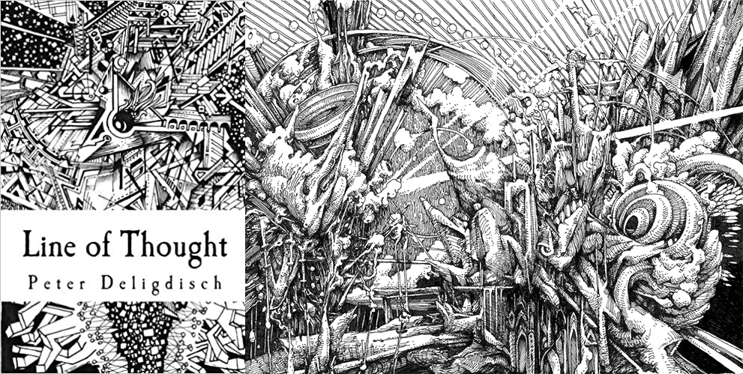  For additional design inspiration I also looked at a team of artists known as ‘Creature Box’¹¹. These artists have a mastery over shape and form and share a similar genre interest of sci-fiction, hybrids and robots.  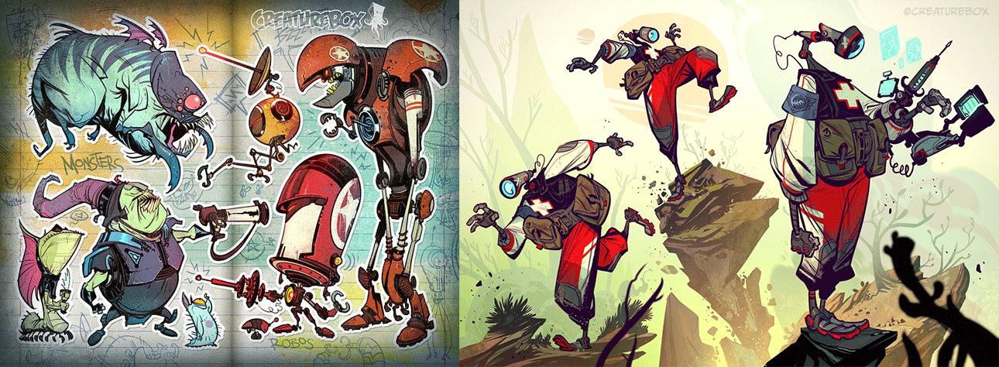  For environmental design I studied Matt Sanz’s¹² work, an expert environmental concept artist who creates vibrant and colorful work.  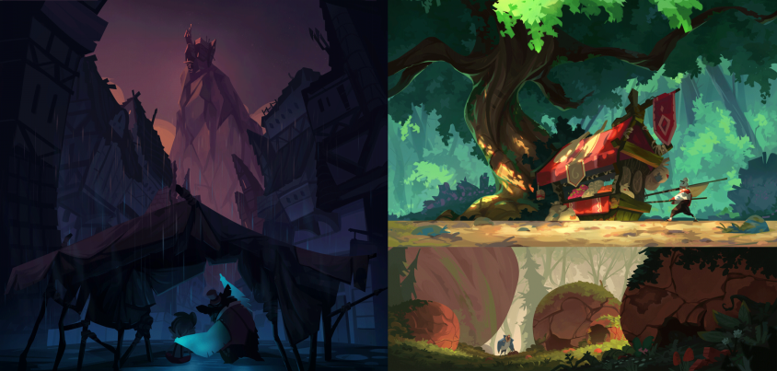  RESEARCH QUESTIONS EXPLAINED:  Q1.  How do I make a unique world? In a time of many ideas not being very original, how do I foster an approach that lets me develop an original world told through visual communication?  A1.  The answer I came up with was not to obsess over coming up with an idea in the first place. The more time I spent genuinely trying to come up with something unique and special, the harder I found it to think of something with potential. After some creative writing exercises and surfing the web, something I read online triggered me into remembering the famous quote “one man's trash is another man's treasure” by Yotam Ottolenghi. This quote led me to making further connections and began forming the basis of my world. There is some evidence as well to support that our random fleeting thoughts end up being the most creative and unique. ‘Jungian Psychoanalysis: Working in the Spirit of Carl Jung’¹³ further supports this, and encourages people to record the thoughts that strike us randomly at idle points in our day.  Q2.  How does this world’s society function? What sort of parameters affect my world? How do the creatures of my world interact with one another?  A2.  The world of the Knock Rift has a chaotic society. With rift dwellers coming in all shapes and sizes, it is difficult to police them - and the Knock Rift does not have a single overreaching authority. Rather, a collection of elites take control and intimidate others and lord over them - similar to a gang. These elites manage the distribution of resources and control supply and demand, thus leading them to lining their own pockets. The rich get richer and the poor get poorer due to this massive ever-increasing difference in wealth. These parameters lead to many different behaviors among the populace. Scavenging and scouring to find trash that can be useful to someone else, and wanting to barter it for profit is the main activity among the people. Some downtrodden rift dwellers will even sell off pieces of themselves when pushed to the brink of starvation. All for just a few drops of Slurp.  Q3.  What do the creatures of my world look like? What separates an individual from another?  A3.  The visual makeup of the rift dwellers have one main principle behind it, Anything goes.  Due to them being made of alien trash, these creatures are smashed together messes of all kinds of junk. They come in all shapes and sizes and have different mannerisms and ways of moving and communicating.  RESEARCH METHODOLOGY:  Due to the speculative nature of this dissertation, all research was qualitative. It is possible to shoe-horn in quantitative methods but it did not seem appropriate or useful to do so. Books and movies were first studied in an attempt to derive inspiration from similar works. After grasping a sense of understanding regarding key elements of story-telling and systems of world-building, it was then time to begin the next phase of my research.  I took a look at artists and illustrators who could inspire design direction. Doing so I came across a few artists such as Peter Deligdisch and Creature Box who would lead me to developing my visuals.  DATA SOURCES:  original artworks, personal narratives, books, articles, movies and websites such as (books.google / wikipedia / sites.coloradocollege / amazon / artstation / behance / webnovel / youtube / goodreads / docs.google)  MEDIUM OF PRESENTATION:  The medium will be a printed book as well as E-book format for digital reading. The book will feature digital illustration - assembled together with text as an illustrated encyclopedia. Tools used include Adobe Photoshop, Adobe Illustrator and traditional pen on paper. The project will use designs made on traditional pen and paper and then further developed using digital painting techniques in Adobe Photoshop and vector based illustrations in Adobe Illustrator. Layout and typography is also designed within Adobe Illustrator.  PRE-PRODUCTION:  Initial experiments with designing creatures of my world were not successful.  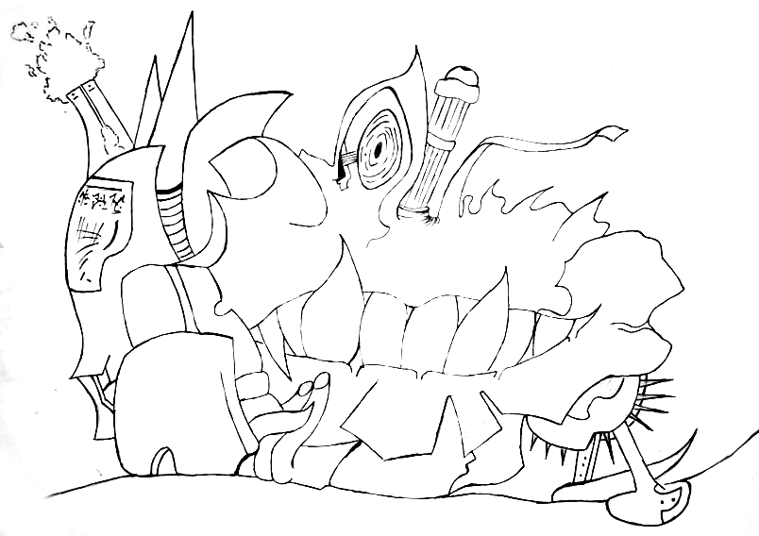  This image was one of my earlier designs yet I was unhappy with my outcome. I felt as if I was overly humanizing the creature in it’s design with eyes and mouth. Doing so to some extent is fine but I didn’t want my creatures to seem overly cartoon-like. After studying Peter Deligdisch’s artwork, I then began branching into different types of design.  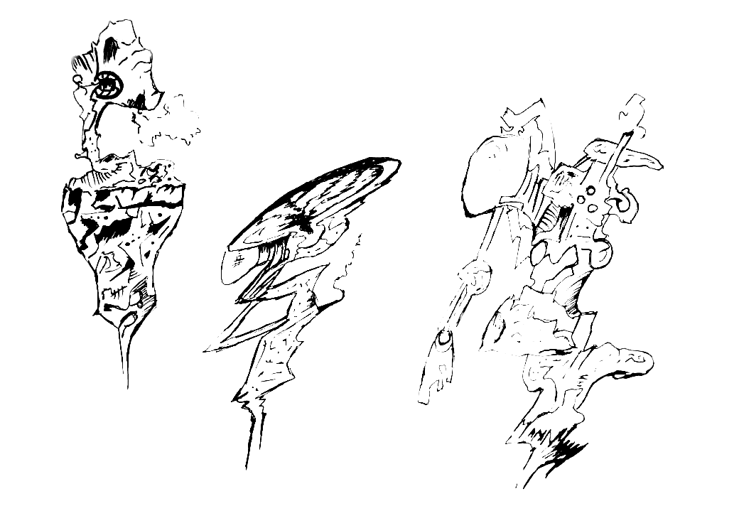  These are some early sketches that would then make way into the art style of the creatures of my world. This sort of design that seems intricate and doodled better suited my intentions.  PRODUCTION:  After understanding the direction of my design, I began combining colors and digital painting techniques to start creating my final illustrations that would then be assembled into my illustrated encyclopedia.  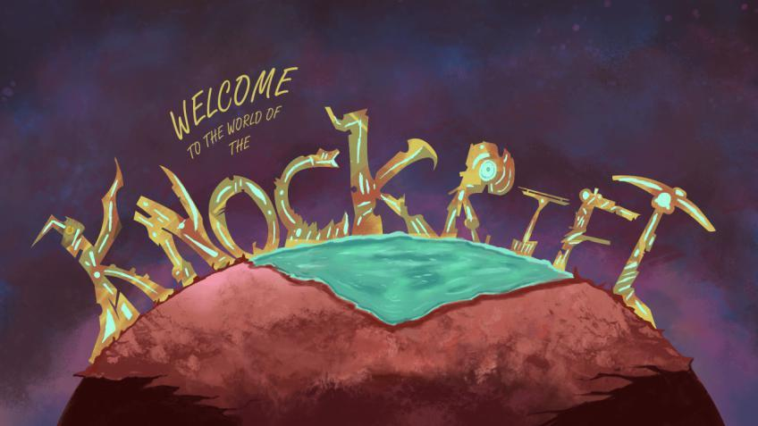  This is the cover page of my illustrated encyclopedia. It contains a focus on the typography but also includes elements that you will find on the Knock Rift, such as the liquid which represents slurp and the reddish brown land.  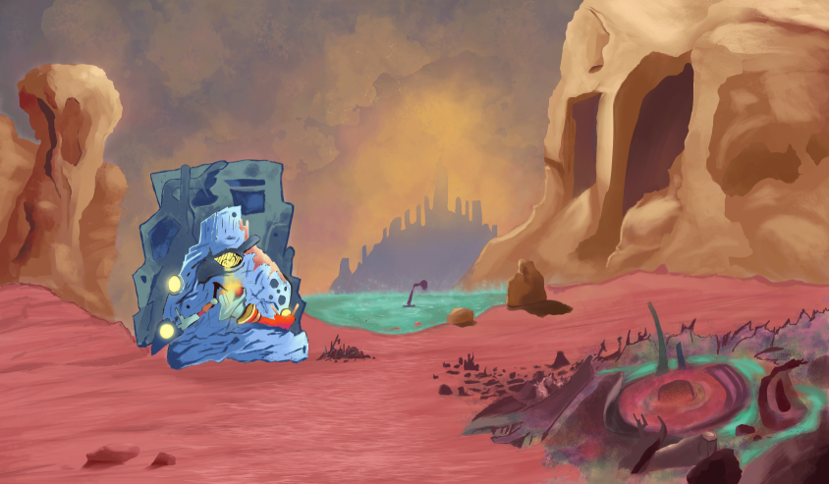  This illustration features a rift dweller close to a pile of broken junk whose identity remains ambiguous. The rift dweller seems to be tinkering with certain parts scavenged from the junk pile - with the backdrop being a pool of slurp and a rocky / dusty background.  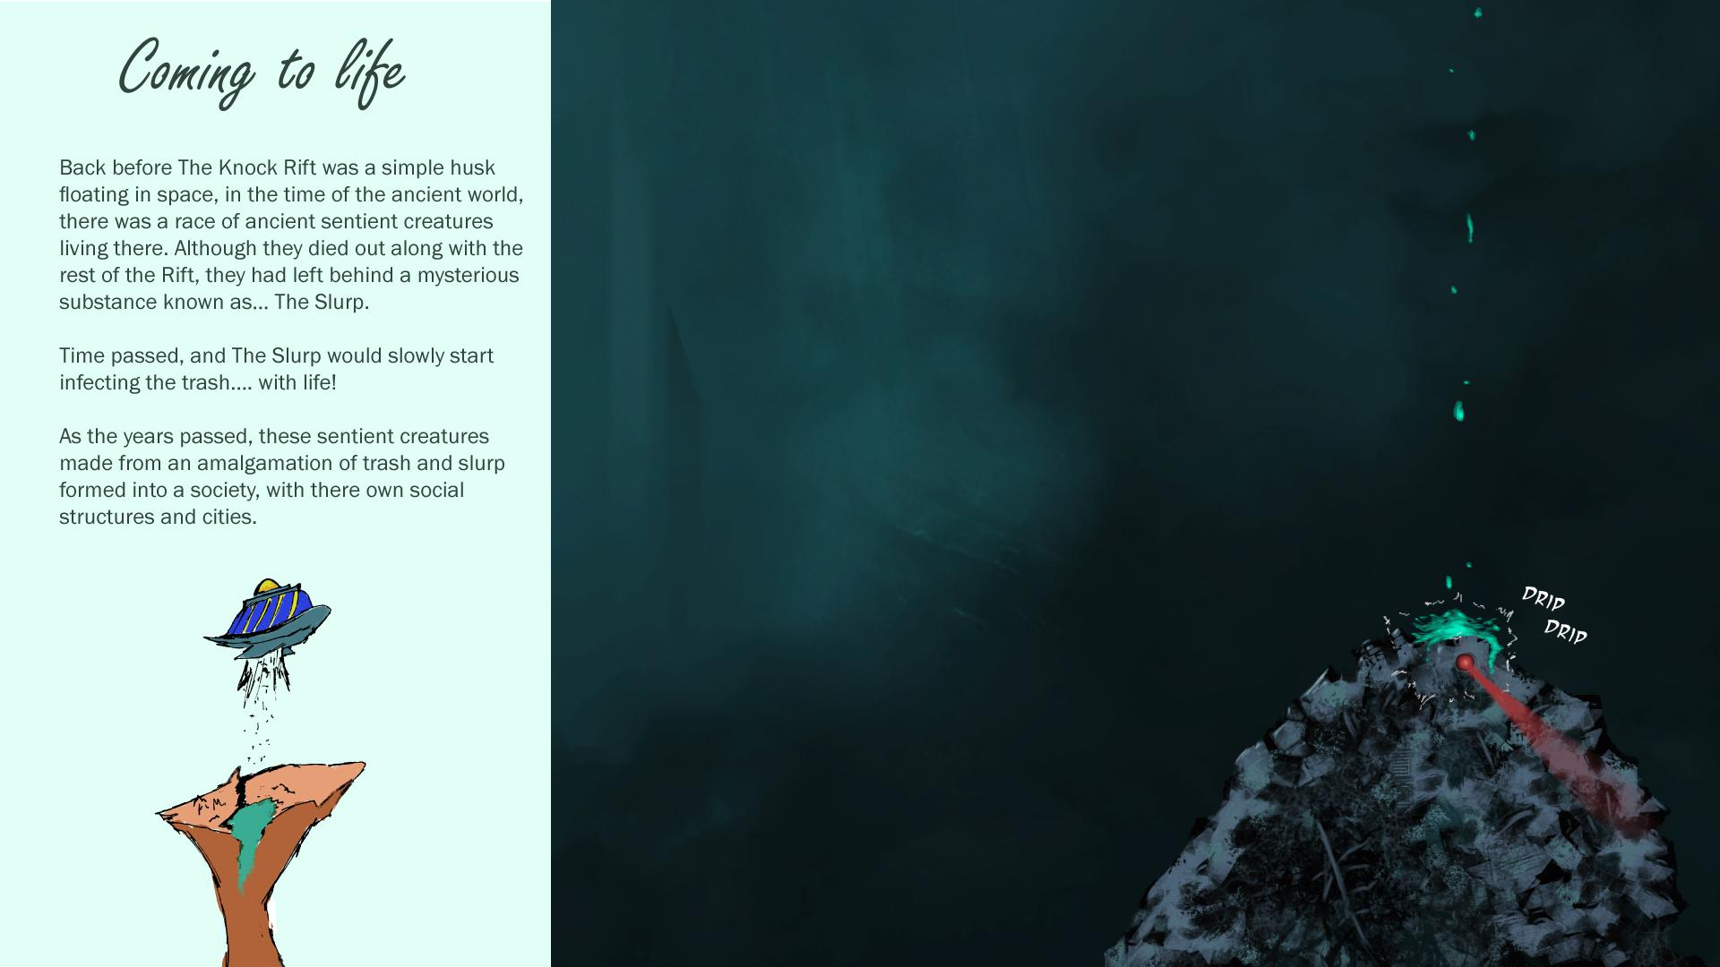  This page is a good example to show what the illustrated encyclopedia will overall appear as. Some simple illustrations and more detailed illustrations are shown - that explain and give insight into the narrative given by the text accompanying it.  CONCLUSION  When I first began this project, I had hoped to take a step in the right direction and realize my dreams. Since I was young, I have aspired to be someone who can craft stories and worlds that would interest others. This project encapsulates this idea. I tested myself and my ability to craft a place unlike any other and show my ability as a concept artist, illustrator and story-teller.  In my journey, I learned the value of analyzing and researching the reasons behind certain creations and ideas - as well as how to correctly take inspiration from and adopt the methodology of other contemporaries.  Looking at the world of the Knock Rift, I have created a visual guide through my illustrated encyclopedia that can in the future also serve as the bases of further development, such as a comic book or animation.  BIBLIOGRAPHY  Deligdisch P, (2013), Line of Thought, An Art Collection by PeterDraws  Adams, D, (2004), The hitchhiker's guide to the galaxy, New York: Harmony Books  Yotam Ottolenghi Quotes, (1968.), BrainyQuote.com, Retrieved May 31, 2020  Willard, F, (2008), WALL-E, Burbank, Calif: Walt Disney Home Entertainment  Niccol A, (2011), In Time, Abraham M, Newman E, United States, New Regency Strike Entertainment  Tang Jia San Shao, (2008), Douluo Dalu, Qidian  Murray S, (2010), Jungian Psychoanalysis: Working in the Spirit of Carl Jung, Carus Publishing Company, pg.95  Dave & Greg, n.d, United States, creaturebox.com  Sanz M, n,d, United Kingdom, mattsanz.artstation.com

